Diodes: Vehicle Usage
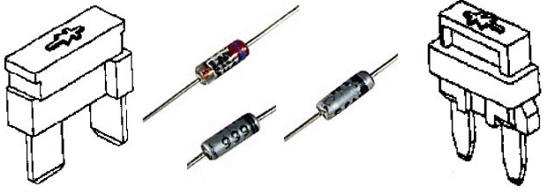

- Generator (Alternator) Rectifier Bridge
- A/C Compressor Clutch
- Transmission Shift Solenoids
- Engine Cooling Electric Fan (Relay)
- Rear Defog Electric Grid (Relay)
- Door Lock Solenoids
- Headlamps (Relay)

